Anatomy & Physiology: Tissue Exam

1) Each of the following is a primary tissue type except one. Identify the exception.
A) muscle tissue B) nervous tissue
C) bone tissue D) connective tissue E) epithelial tissue

2) Epithelial cells that are adapted for absorption or secretion usually have __________ at their free surface.
A) many mitochondria B) nuclei C) microvilli D) Golgi complexes E) junctional complexes

3) A type of intercellular connection in which the outermost portions of the two cell membranes have a tight seal
together is termed a(n):
A) tight junction. B) gap junction.
C) intermediate junction. D) desmosome. E) none of the above

4) Dead skin cells are shed in thick sheets because the strong links are held together by anchoring junctions
called__________.
A) gap junctions B) intermediate junctions
C) tight junctions D) desmosomes E) junctional complexes

5) The basic shapes of epithelial cells include all but which of the following?
A) stratified B) squamous
C) cuboidal D) columnar E) All of the above are correct shapes.

6) The type of epithelium that is found lining internal body compartments, blood vessels and lungs is
A) simple squamous. B) stratified squamous. C) simple cuboidal.
D) stratified cuboidal. E) transitional.

7) The type of epithelium found where absorption or secretion takes place and is found in the kidney tubules is
A) simple squamous. B) simple cuboidal. C) stratified squamous.
D) transitional. E) pseudostratified squamous.

8) Simple Cuboidal Epithelium can be found…
A) at the surface of the skin. B) lining the trachea. C) lining blood vessels.
D) lining the ovaries. E) lining the air sacs of the lungs.

9) A Transitional Epithelium can be found…
A) lining the urinary bladder. B) lining the ducts that drain sweat glands.
C) lining kidney tubules. D) lining the stomach. E) at the surface of the skin.

10) One would find Pseudostratified Columnar Epithelium lining the
A) upper respiratory tract. B) intestines
C) heart. D) surface of the skin. E) stomach.

11) Which of the following is a type of secretion in which some cytoplasm is lost with the product & is found in the
mammary glands?
A) holocrine B) merocrine C) apocrine D) mucous E) none of these

12) Functions of connective tissue include
A) establishing a structural framework for the body. B) transporting fluids and dissolved materials.
C) providing protection for delicate organs. D) storing energy reserves.
E) all of the above.

13) Cells that store fat are called
A) fibroblasts. B) macrophages. C) adipose cells.
D) mast cells. E) melanocytes.

14) The dominant (strongest) fiber type in dense fibrous connective tissue (Areolar) is:
A) collagen. B) elastin. C) actin. D) myosin. E) cartilage.

15) Chondrocytes are to cartilage as osteocytes are to
A) blood. B) fat. C) epithelium. D) bone. E) nervous tissue.

16) The muscle tissue which shows no striations is
A) skeletal muscle. B) smooth muscle.
C) cardiac muscle. D) voluntary muscle. E) multinucleated muscle.

17) The muscle that is located in the walls of hollow internal organs is
A) skeletal muscle. B) smooth muscle.
C) cardiac muscle. D) voluntary muscle. E) multinucleate muscle.

18) The neuron is made up of all of the following EXCEPT: (remember the hand/arm model)
A) cell body. B) dendrites. C) an axon. D) nucleus. E) a synapse.

19) Salivating is an example of what type of secretion?
A) Merocrine/Eccrine B) Holocrine C) Apocrine D) Serous E) Endocrine

20) Cells that remove damaged cells or pathogens from connective tissue are
A) fibroblasts. B) adipocytes. C) melanocytes. D) macrophages. E) mast cells.

21) Skeletal muscle differs from the other two types of muscle tissue in that skeletal muscle
A) has visible striations. B) has only one nucleus per cell.
C) is the only muscle tissue controlled voluntarily D) contains actin and myosin filaments.
E) forms muscle fibers.

22) Close examination of an organ reveals a lining of several layers of cells. The layers are avascular and can
regenerate well. One surface of the cells is open to the internal cavity of the organ and protection and absorption
are its functions. This tissue is probably
A) epithelium. B) muscle. C) nervous. D) connective tissue. E) fat tissue.

23) Types of epithelial tissue include all of the following EXCEPT
A) cartilage. B) simple squamous. C) glandular. D) pseudostratified columnar. E) transitional.

24) Types of muscle tissue include
A) skeletal, smooth, and fibrous. B) simple squamous, adipose, and smooth.
C) skeletal, smooth, and cardiac. D) bone, elastic connective, and simple columnar.
E) fibrous connective, stratified squamous, and skeletal.

25) Ligaments attach (Who are my kids?)
A) Muscle to Bone B) Bone to Bone C) Muscle to Muscle D) Tendons to Muscle

26) Examples of fibrous connective tissue include
A) tendons. B) salivary glands. C) respiratory passages. D) ligaments. E) A and D only.

27) Which of the following is the correct order of Tissue Repair (Remember your drawing!!!)
A) Organization restores blood supply, Inflammation & clotting and Regeneration and fibrosis effect
permanent repair
B) Regeneration and fibrosis effect permanent repair, Inflammation & clotting, & Organization restores
blood supply
C) Inflammation & clotting, Regeneration and fibrosis effect permanent repair & Organization restores blood
supply
D) Inflammation & clotting, Organization restores blood supply & Regeneration and fibrosis effect
permanent repair

MATCHING. Choose the word or phrase that best completes each statement or answers the question.
WORD BANK:
A) Exocrine B) Matrix C) Histology D) Pathologist E) Endoderm
AB) Neurons AC) Mesoderm AD) Stem

28) The study of tissue is called __________.
29) Secretions onto body surfaces are characteristic of __________ glands.
30) Unspecialized epithelial cells which act as a source for mitosis are called __________ cells.
31) The combination of fibers and ground substance in supporting connective tissues is known as __________.
32) __________ are cells that are modified to transmit signals from one place to another.
33) The ___________ is the germ layer that differentiates into the GI track, bladder & respiratory tract.
34) The ___________ is the germ layer that differentiates into muscle tissue & connective tissue
35) A person who studies diseased tissues and performs autopsies is a(an) ____________________.
MICROSCOPE VIEW MATCHING:
A. Stratified Squamous B. Hyaline Cartilage C. Bone D. Nervous E. Cardiac
AB. Areolar AC. Skeletal Muscle AD. Adipose AE. Simple Cuboidal BC. Smooth Muscle
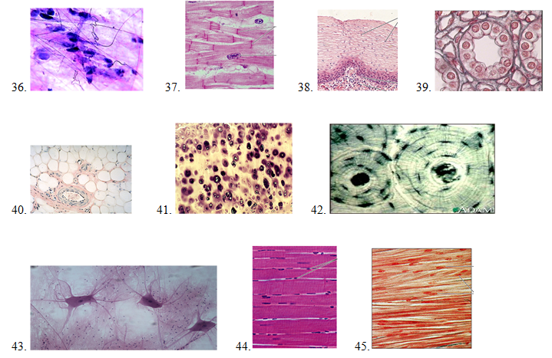

True/False (A= True & B =False)
46. Blood is a tissue.
47. Elastic cartilage is found in the ears, nose, epiglottis and larynx.
48. If you have a neoplasm you hope it is benign.
49. All cancers are neoplasms but not all neoplasms are cancer.
50. Plasma cells produce Histamine
51. The liver is one organ that can partially regenerate because it is made of epithelial cells
52. Keratin is a waterproofing protein found in epithelial cells

Diseases Matching:
53. VAC a. any glandular neoplasm, benign or malignant
54. Healing by 2nd Intention b. healing is slower than in wounds where edges are brought together
55. Lesion c. any injury, wound, or infection that affects tissue over an area of definite size
56. Pus d. genetic disease; abnormality of connective tissue
57. Marfan’s Syndrome e. collection of tissue fluid, bacteria, dead/dying tissue, & WBC in inflamed area
58. Scurvy ab. Nutritional deficiency of Vit. C needed to synthesize collagen; delay wound healing
59. Adenoma ac. Healing process for open skin wounds; skin stretching = promotes healing

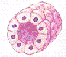
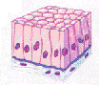
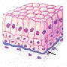
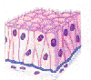
Tissue Drawing Matching (Look Familiar?):
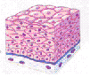
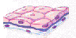

A. B. C. D. E. AB.

60. Stratified Squamous 61. Transitional Epithelium 62. Pseudostratified Columnar
63. Simple Columnar 64. Simple Cuboidal 65. Simple Squamous
Lab Practical
Go to each station and look in the microscope (do not move ANYTHING!). Which tissue are you viewing?
66. Station 1
A. Simple Squamous B. Simple Cuboidal C. Simple Columnar
D. Pseudostratified Ciliated Columnar E. Stratified Squamous AB. Transitional
AC. Bone AD. Hyaline Cartilage AE. Dense Fibrous
BC. Areolar BD. Adipose BE. Smooth Muscle
CD. Cardiac Muscle CE. Skeletal Muscle DE. Nervous

67. Station 2
68. Station 3
69. Station 4
70. Station 5

BONUS WOTD
(Put answers on the back of the scantron on the green line)
- “EPI” MEANS __________
- “-OSIS” MEANS _____________
- ______ MEANS inflammation
- ______ MEANS tumor.

